difficult_wk_wd.csv
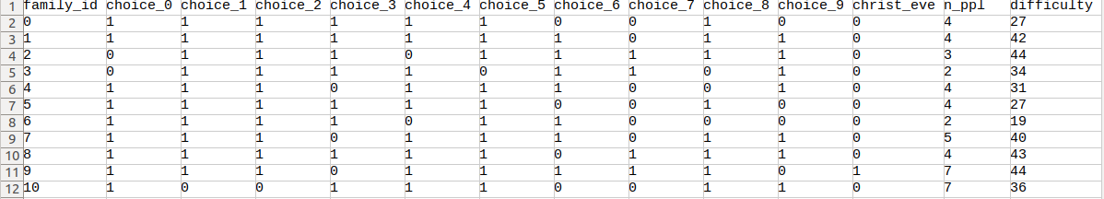
familys_difficult.csv
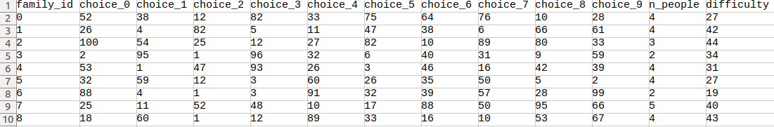
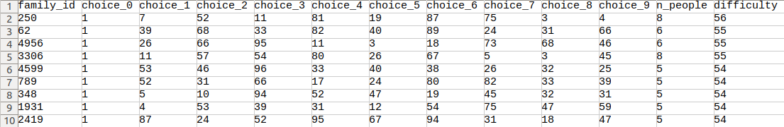
familys_difficult_sort.csv

